Process
https://www.youtube.com/watch?v=KNXvnbxU61w
Passive Voice: Cambridge Grammar for IELTS Ex. 1 p194
There are 5 key steps of describing a process:
- Rewrite the introduction
- Write an overview
- Use only the Present Simple Tense
- Link with sequencers and reference words
The diagram shows the stages involved in the process of making leather goods.
Summarise the information by selecting and reporting the main features, and make comparisons where relevant. Write at least 150 words

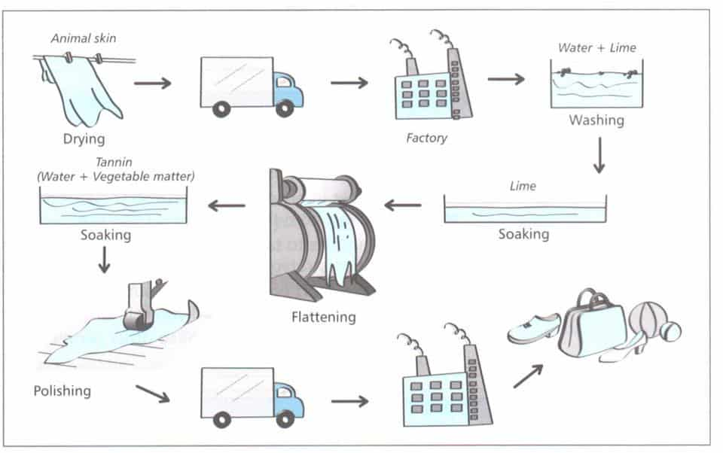

Process diagram Step 1: Rewrite the introduction
Re-write the introduction in your own words.
Simple option:
- Keep the basic sentence structure but use synonyms.
- Don’t try to change every word – this would sound unnatural.
e.g. The diagram shows the stages involved in the process of making leather goods.
Re-write as: The images illustrate the steps involved in the production of leather goods.
This is a safe option, as it keeps the same sentence structure.
Advanced option:
- You could use a more complex sentence structure: change the word order and use the verb in the Passive
e.g. The diagram illustrates how animal skins are processed in order to produce a range of leather items such as shoes, handbags and toys.
Using the Passive Tense gives you an instantly sophisticated, complex and academic option.
Here’s another example:
e.g. The illustration depicts the numerous steps involved in the treatment of animal skins before they are turned into leather products such as handbags and shoes.

Process diagram Step 2: Write the overview
Many people DO just repeat what they’ve already said e.g.
‘Overall, the diagram shows that many items can be made from leather.’
This is better than no overview, but it is too obvious, too vague and there is no analysis.
- You need to say something noticeable about the process.
Here are some examples:
Overall, the diagram shows that it is necessary for animal skins to undergo a number of treatments before they can be made into everyday household items. The process is still a complex and lengthy one despite being mostly done by machinery rather than by hand.

Overall, the diagram shows that, despite the fact that the process of treating animal skins so that they can be made into everyday household items is done mostly in factories with the help of machinery, it is still lengthy and complex, involving several stages.
Should the overview go at the start or at the end?
It doesn’t matter. The overview can go just after the Introduction, or at the END of the description.

Process diagram Step 3: Use the Present Simple
The diagram gives you several of the verbs that you need to describe each stage e.g. drying, soaking, polishing, flattening.
Again, you have the problem of avoiding using these words exactly as they are in the text.
So using the Present Simple (Passive) Tense gives you an easy solution.
The only thing you have to worry about is whether you need Singular or Plural. Both are possible here and both are correct.
e.g. The skins ARE dried OR The skin IS dried.
The skins ARE polished OR The leather IS polished.
(see quick review of Passive Tense below)

Process Diagram Step 4: Use a variety of linking words
Now you’ve got a list of stages all written in the Passive Tense, you need to put them all together NICELY with a variety of linking words.
One problem many people have is that they just put the linking words at the start of the sentence. This can sound repetitive, and it is important not to OVERUSE linking words.
- Don’t choose a different linking word for the start of every sentence. Use some in the middle
e.g. the process by which leather is treated, the liquid in which the skins are soaked, the place where the skins are flattened.
Compare these two versions:
Version 1: simple, accurate but a little ‘mechanical’
The skin is dried. Then it is taken to a factory. In the factory it is washed in water and lime, then soaked in lime and flattened and submerged in tannin. After that it is polished and taken to another factory. In the factory it is turned into leather goods.
Version 2: More fluent and natural
In the initial stages of the process, the skin is dried before being taken to a factory where it undergoes two treatments. Firstly it is washed with water and lime, followed by a soak in lime and then flattened, after which it is submerged in tannin.
The last stage involves polishing the leather with a roller. The pieces are subsequently transported to a processing factory where they are made into a number of items in preparation for shipping.

Step 5. Add the ‘Band 7+’ finishing touches
In 4 steps, you have completed all that needs to be done for a very good Task 1.
But what if you want to make it even better? Have a look at this final example – what kind of changes have been made to give it a little extra magic?

The diagram illustrates how animal skins are processed in order to produce a range of leather items such as shoes, handbags and toys.
In the initial stages of the process, the skin is air-dried before being loaded onto trucks and taken to a nearby factory where it undergoes two chemical treatments to clean and soften it. Firstly it is washed with a mixture of water and lime, and then it is soaked in concentrated/pure lime and pushed through a rolling machine in order to flatten it, after which it is submerged in a vat of tannin, which is a substance derived from vegetables.
The last stage involves polishing the leather with a roller to improve its appearance. The pieces are subsequently transported by road to a processing factory where they are made into a number of everyday products like footwear and sports items in preparation for shipping.
Overall, the diagram shows that, despite the fact that the process of treating animal skins is done mostly in factories with the help of machinery, it is still lengthy and complex, involving several stages.
You can:
- say WHY something is done (in order to.., so that…) (to soften the leather, to remove impurities)
- give extra details (transported by road, which is a substance, a mixture of)
- give more examples (like footwear and sports items)
- add adjectives (air-dried, everyday products, a nearby factory)
- use useful connecting words: first / first / first, second, third. then / next / then / then / from here / then / then finally

The diagram below shows how electricity is generated in a hydroelectric power station.

Summarise the information by selecting and reporting the main features, and make comparisons where relevant.

HYDRO-ELECTRIC POWER GENERATION

The diagram below shows how electricity is generated in a hydroelectric power station.

Summarise the information by selecting and reporting the main features, and make comparisons where relevant.

